Section 2

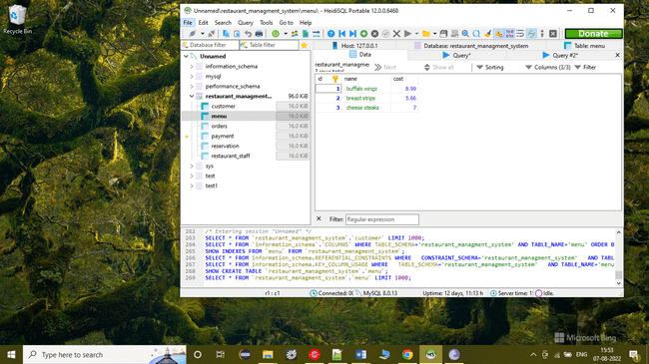

insert into menu (id,name,cost) values(4,'cheese strips',8)

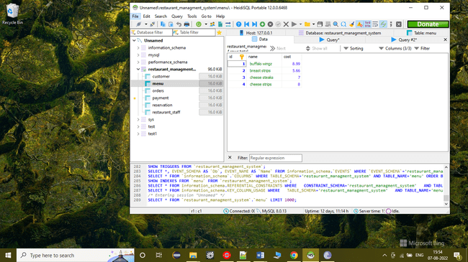

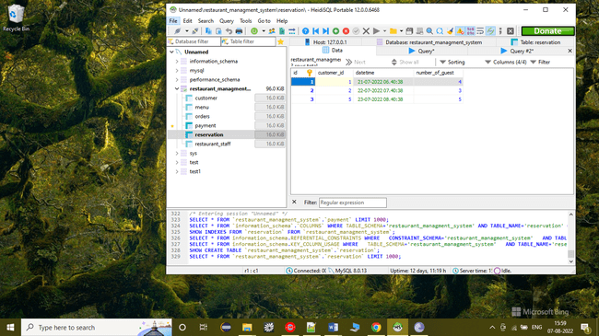

**UPDATE** reservation **SET** number_of_guest = 7 **WHERE** id = 3

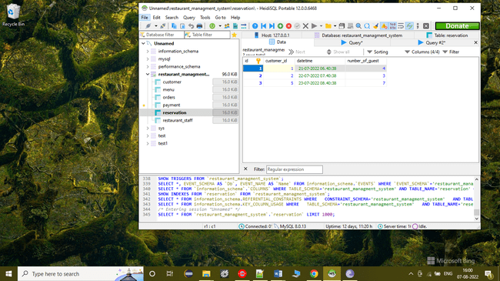

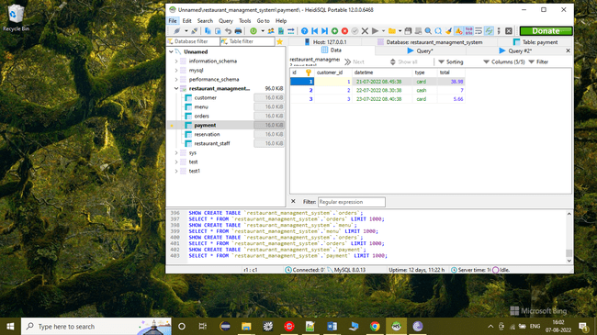

DELETE FROM payment WHERE id = 3

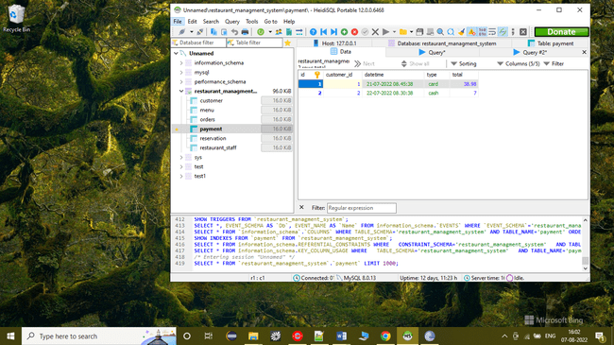

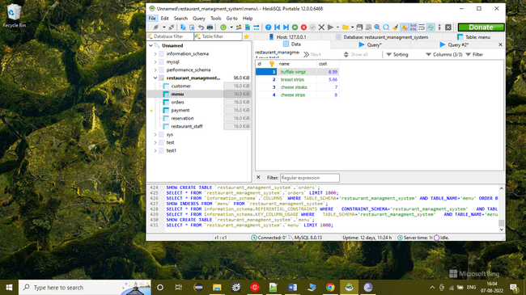

**SELECT** * **FROM** menu **ORDER** **BY** cost

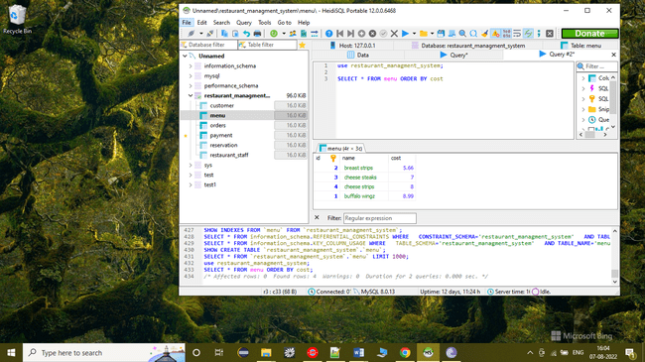

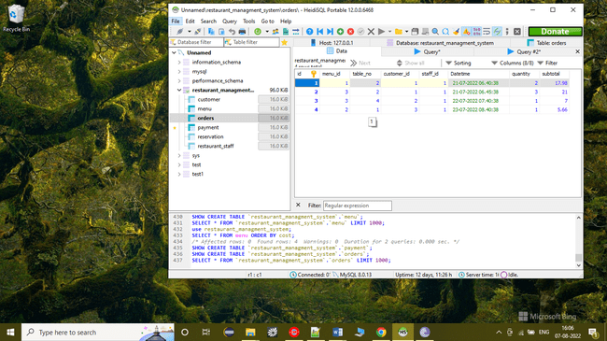

**SELECT** * **FROM** orders **WHERE** quantity >2

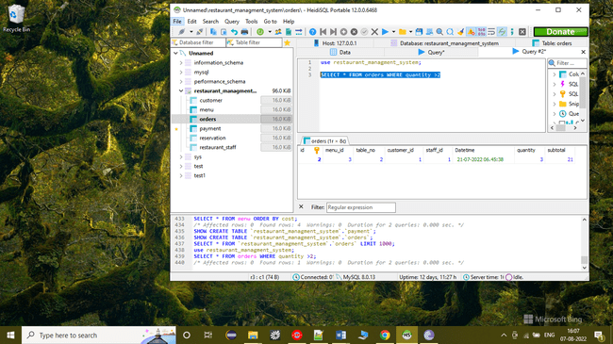

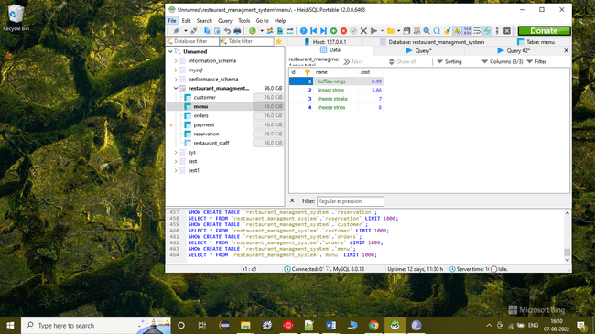

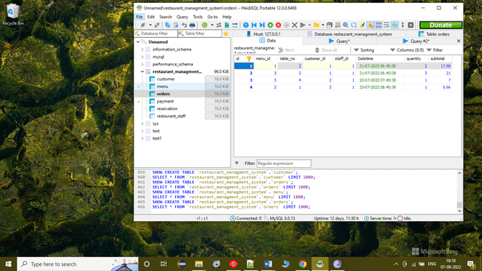

**SELECT** o.id,o.customer_id,o.table_no,m.**name** **FROM** orders o **JOIN** menu m **ON** o.menu_id = o.id

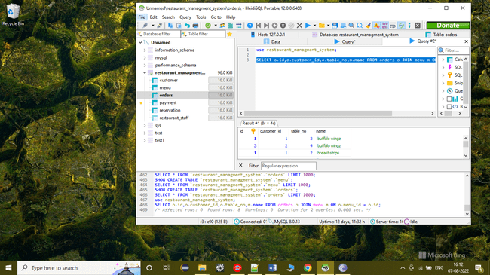

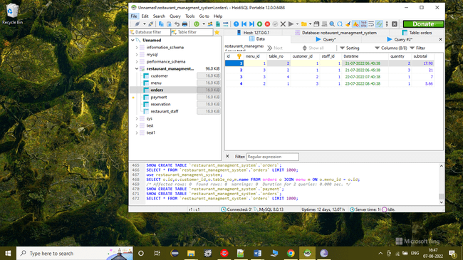

**select** **sum**(subtotal) **as** total,customer_id **from** orders **group** **by** table_no,customer_id

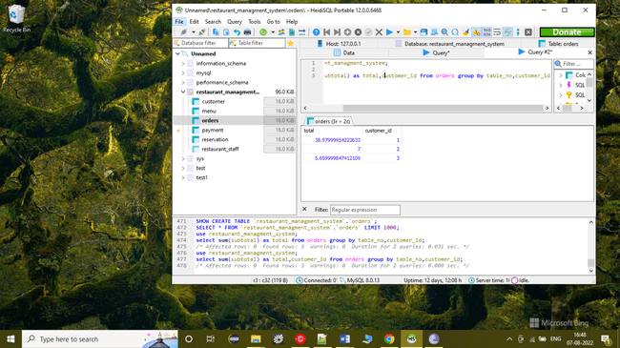

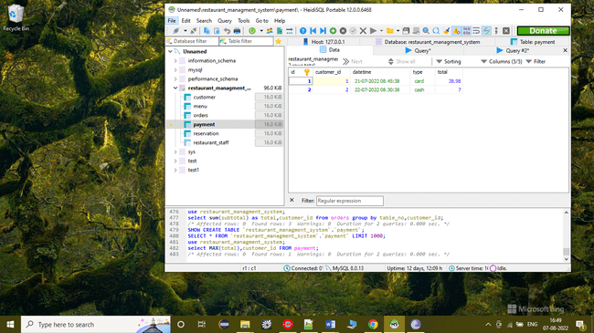

**select** **MAX**(total),customer_id **FROM** payment

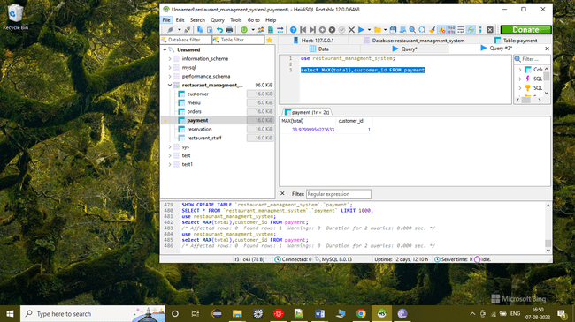

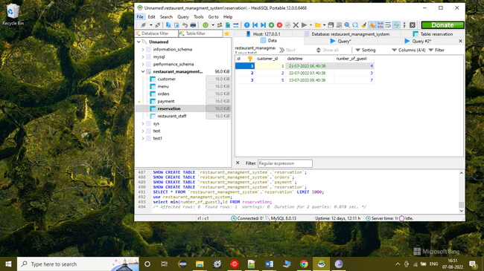

**select** **min**(number_of_guest) **AS** min_of_guests,id **FROM** reservation

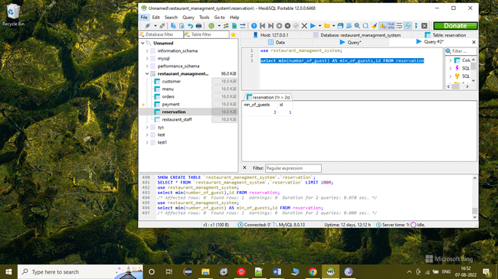

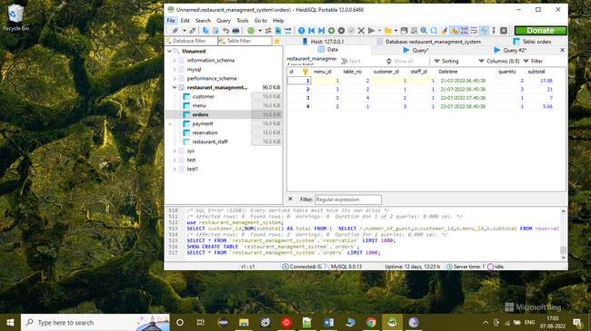

SELECT customer_id,SUM(subtotal) AS total FROM (

SELECT r.number_of_guest,o.customer_id,o.menu_id,o.subtotal FROM reservation AS r JOIN orders AS o ON

r.customer_id = o.customer_id

) AS temp GROUP BY customer_id

